10 October 2024 postcard

Paris!

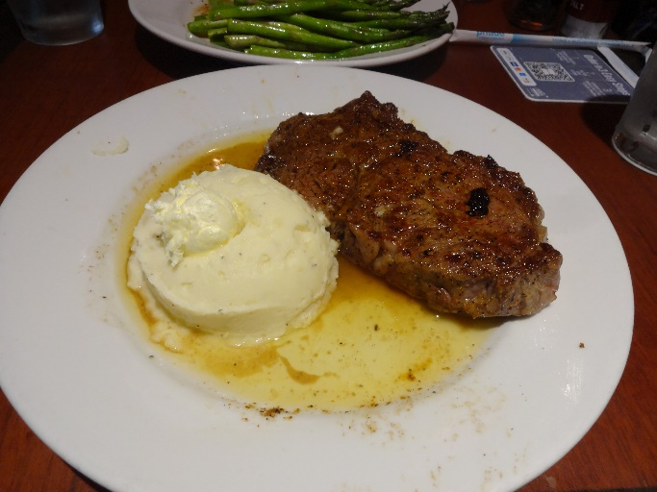

We had a nice steak dinner at Longhorn in the Atlanta airport last night, with the result that I had no appetite for the nice dinner of braised beef short rib that Dleta served us just two hours later.

They also fed us a frittata, muffin, and fruit-and-yogurt parfait before we landed at 12:30 pm, so we just skipped lunch and went straight to dinner at La Régalade on the rue Saint-Honoré.

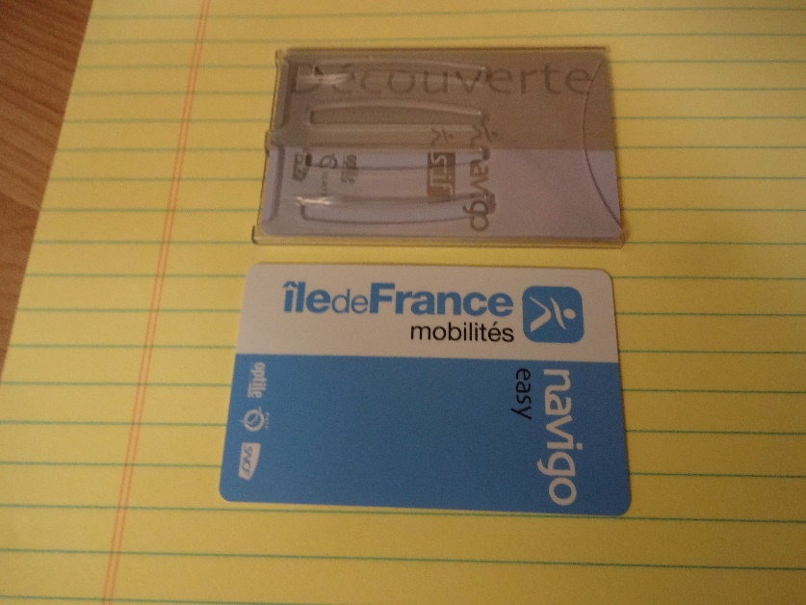

In between, we walked from our hotel to the Bastille metro station to arrange for our transportation for our time in Paris.

Even after considerable study of the relevant website, I was pretty confused about our options, so I presented these two cards from previous visits, plus an old "Paris Visite" tourist pass, to the friendly ladies in the kiosk, and they explained it all and set it up for us. The card in the plastic sheath at the top (the "Navigo Découverte") is a commuter transport pass. On the back it has my photo and signature—we acquired it for a longer stay in Paris a couple of years ago. It's the cheapest option by ride and can be loaded with unlimited public transport of any kind (metro, bus, tram, funicular) in Paris, by the week, month, or year. We're here for eight days this time, but a week on the pass can only run from Monday through Sunday. So we bought a week for each of us, which will run through midnight Sunday. For Monday and Tuesday, they recommended loading the blue "Navigo Easy" card with a "carnet" (booklet) of 20 individual transport tickets, again good on any kind of transport. They didn't recommend the "Paris Visite" option, which is still available in 1-, 2-, 3-, and 5-day denominations, to begin on any day, because it's being phased out and is the most expensive option.

At La Régalade, I had tartare of "white veal" with spinach sprouts and lime, all showered in grated mimolette cheese (pictured), followed by braised pork belly with soubise of onions and Comté cheese. David started wih chanterelle mushrooms sautéed with meat juices and ham (pictured), followed by duck breast roasted rare with shiitake mushrooms and a sauce of fresh damson plums. All excellent!

